August Transmutation News 2018 Download printable version

I want to thank everyone for the beautiful messages I received about the July Transmutation News.

I know many of you are sensitive and might be feeling lost in the current storms of life we are experiencing. I wanted to share some things from own life without writing an entire autobiography.

I grew up in a typical neighborhood in Brooklyn that is often depicted in comedy shows on TV. But life was not funny as people struggled to take care of themselves and their children.

My father had a small store a few blocks from our house. I would either go to visit after school or sometimes work there. I loved being outside and playing sports with my friends or in my house writing fictional stories. But I did spend quite a bit of time helping at the store.

When I would walk to my father’s store there would always be someone who would stop me and ask if I was willing to talk. I was only about 7 and would always stop to listen. I remember one day the wind was so strong. And you know how on city streets when the wind is so strong it blows dirt and garbage like a tornado around your feet. I remember one day garbage and dirt was blowing around me while an elderly man asked to speak to me. I don’t remember the conversation. I remember the scene and his face so clearly. But he thanked me at the end of our time together for my kindness and listening to him.

These kinds of events kept happening. And there were customers who would come into the store to simply talk to me and of course felt obligated to buy something. I remember a beautiful nun in a full habit who would often come to speak to me and then tell me what a special child I was. I am not aware at this point of how I helped so many, but I was a stellar listener and always had a smile for people.

Then when I was about 13 I could see I had come become quite depressed. And although I grew up around people who were suffering, including my own family, I was quite a happy child. But I noticed this happiness had left me. I would sit on my bed and wonder why I felt so sad all the time. And at that point I realized I was taking on the pain of others around me.

Fast forward to my later teenage years when the Vietnam War began. I was outraged. I always supported those who went to war and of course many of my dear friends were drafted. But I felt the war was unjust, and I participated in demonstrations on Wall Street where bottles were thrown at us and the police would set off tear gas as we marched the streets.

When I realized that my efforts had no impact on creating a change I guess I had what some would call a nervous breakdown, but I could still work, go to school, and function in the world. For my own survival I knew I had to do something drastic for my own mental health, and I stopped watching any news or reading the news. I did not even know who the president of U.S. was for about 10 years. I experimented with drugs, moved to a commune in San Francisco, and started to explore alternative ways of living.

In a true organic progress, I started to heal. During my years in San Francisco I left the commune, enrolled in San Francisco State to get my BA in Biology, specializing in Marine Biology, and loved all that I was learning. I worked at the Student Learning Center. The manager would sit at the front desk and always had the newspaper on his desk. One day after a year or so of working there I found myself reading the headline on the front page. I did not go past the headlines for months until one day I started to read articles and this was my entrance into finding my way back into knowing about what was politically occurring.

My story continues with various situations like this. But my saving grace was that I did have a lot of access to the unseen realms through my own predisposition to spiritual work, my Near Death Experiences, and all the plant spirit medicine I worked with. And then to add to this in 1980 I was introduced to shamanic journeying.

It was through my shamanic journeying that I learned from my helping spirits that I can affect a lot of change through spiritual work. Hence all my teachings and books came out of the wonders of what I was shown about the invisible foundation of positive change we create by the work we do in the non-ordinary realms.

I am sharing this with you as I am hearing from hundreds of people feeling too sensitive to be enveloped by the truly insane and inhumane behavior. We are more visceral than we might realize. But so many have deadened the sense of feeling through finding distractions.

We all have a destiny. And for some people they thrive on being politically active and demonstrating. What a gift to share with the web of life as people defend the rights of all of life. Then there are those whose destiny does not support being that active politically. But our destiny and gift is to be active in the unseen realms weaving a new of fabric of reality that will replace the one that is dissolving. Then there are the people who have the destiny to do both. As I frequently share Gandhi was one example of many who could do both.

We all have gifts to share right now. And if you have to take a “news break” or go on a “news fast” then take care of yourself and do it. A few years ago, I was reading tweets by a wonderful woman who wanted to make the public aware of all the animal cruelty going on in the world. I felt I had to read and see the photos or videos every day to honor these animals and not turn a blind eye to what was happening. And the result was I had quite the meltdown and went off Twitter.

Yes, I have done a lot of work in my life so I could be a psychotherapist and shamanic healer and not get ill by taking on my clients’ issues and pain. But I am too sensitive to be in a true flood of negative energies, heartbreaking news stories, and so much hate. I do keep my ears open, and I am certainly aware of everything going on. But I know I can’t immerse myself in these energies. I stay true to my shamanic work and work on a different level – not better or inferior to what others are doing – just following my destiny.

I can still be a spiritual warrior in bringing about a new world. But I have to honor my sensitivity that makes me a good healer and work on different dimensions of reality to birth through the change. And that is what the Medicine for the Earth work is all about.

And this is why I keep writing books and teaching to inspire people in multiple ways to effect change in the world. To add to this my spiritual work also brings me much needed solace to stay focused and centered during these times.

Honor your destiny of what you came in here to do. If you feel lost in the current storm take a break from the news. Perform the spiritual practices I have been encouraging you to do as I have written since 2000 in the Transmutation News, in my books, and as I teach in my workshops. Many of you have found practices to work with that really support your health and your deeper work to be of service.

It is not just frivolous words when I keep sharing that it is who we become that changes the world. For as we fill up with spiritual energies of love, light, joy, peace, honor, respect, and equality, these qualities naturally birth through us and begin to weave new energies into the web of life.

Never question the work that has been passed down for thousands of years. The reason the practices I share are so powerful is that they work. But yes, it is true that change does not come in the timing we want. I wrote a beautiful section on this in my new book The Book of Ceremony: Shamanic Wisdom for Invoking the Sacred Intro Everyday Life. Shamans have always used ceremony to effect change. And it is time for all of us to bring ceremony into our lives on a very regular basis.

Take care of yourself on all levels and then you will take care of the planet.

I was looking for a message the goddess Isis shared during one of my sessions while teaching an online course. The message I was looking for was on the need to work with our spiritual heart. But I found this one instead, and felt it was appropriate to share now.

Message from Isis

“You have traveled through many different realms to learn about your true nature and to touch into those vulnerable parts of yourself that needed to be strengthened. Your work is far reaching beyond you. For you reflect back parts of the collective that need healing.

We have been living in times where humans have fallen out of harmony with nature and the rules of life itself. It is easy to see the path ahead as more dissolution will occur as so many do not wake up from the hypnotic trance they live in and do not respect life itself.

As I have taught time and time again you can ride a different wave. For beyond this dimension of reality is another veil to open that allows you to step into a new frequency and a new vibration of life. You can travel back and forth between these dimensions building bridges so healing energies can flood this current collective. But you cannot save the collective. And you should not try.

Love is the healing force that all must wake up to. And you cannot force others to open to a state of true unconditional love. First you must begin by loving yourself. Imagine a cup that is overfilled with water flowing in and water flowing out. Your love must flow with ease – it cannot be a forced process.

Once you have experienced the unconditional love of the goddess and unconditional love and acceptance for yourself only then can you share this love and healing power with others. And you hold all in love and trust that what will be will be. There is more than you can see with your ordinary eyes.

But you will always know in your heart that you did show up for yourself and the Earth and all of life. And in that you will carry the energy of a spiritual being who did bring change for all of life.

Stay focused. Imagine walking a path where there is destruction and dissolution to your left and right. But walk the path that is ahead of you putting one step forward and then the next step forward neither looking left or right. Keep walking the path. And know you are held in love by me, and by the gods and goddesses throughout times. The ancient ones sing for you to guide your way. Listen to their song. The descendants sing for you. Listen to how they light your path.

Walk the path to true freedom and let go of all attachments. Just be love.”

Now I will share an excerpt of a message that Isis shared about working with our spiritual heart. The entire message she gave is written in the October 2017 Transmutation News.

“In your world teachers, including your own, encourage you to open your heart to the spirit of love.

But this teaching is not correct on the level of heart that you are being asked to connect with.

For the focus has been on your physical heart which is simply part of your ego. And so many of you are experiencing and seeing suffering which on an evolutional level is expanding your sense of compassion. It takes you so deep into your humanness. But you are still trapped in the energy, vibration, frequency of suffering and that is the energy you are feeding in the world. And by carrying the energy of suffering so many people are becoming ill.

You are now literally and metaphorically being cracked open to the deepest place within where all the knowledge and wisdom is waiting for you to learn from as you touch deeper into your humanness.

Behind your physical heart is a spiritual heart. You do not have to travel that deeply within to connect with it. It is talked about by many gurus, mystics, and spiritual teachers.

And this spiritual heart – one with Source and the joy, bliss, and unconditional love for all of life and creation knows no suffering. It knows bliss, it knows unconditional love, but has no experience of suffering on this Earth.”

People keep writing to me and asking for a variety of prayers for challenges happening all over the world. Please remember that everything we are witnessing in the world today is being birthed through us. Yes, keep praying. But if you don’t examine your ongoing daydreams and stay focused and disciplined with your dreaming work I personally do not see positive change happening. For any change that happens will be birthed through us- it will not come to us.
Our beautiful radiant full moon is on August 26. Let us explore experiencing our spiritual heart to tap into a deeper space within ourselves, perform our preparation work, and join together as a spiritual community to radiate our light and love within and throughout the Earth.

If you are a new reader of the Transmutation News please read “Creating A Human Web of Light” on the homepage for the instructions of how to join us in our monthly ceremony.

Announcements:

I have loved teaching online courses, and I do realize that they can only take participants so far into shamanic work. I do plan on scheduling some physical workshops at retreat centers for people looking for workshops where we can be together physically and where I can teach shamanic healing methods. Please continue to check my Training section on the homepage and please stay signed up on my email list. I miss holding hands in circle, singing and dancing, and laughing together!

Time is speeding on! And my two new books are ready to pre-order on Amazon. I am so excited!! And I hope you will be too. They are fabulous books, and I am so proud of both.

I will be sending out a dedicated email in the next days with an excerpt from The Book of Ceremony pre-order information.

Here is the write up for both books:

The Book of Ceremony: Shamanic Wisdom for Invoking the Sacred into Everyday Life

Ceremony is a central part of human life and spiritual practice, yet in today’s world, many of our ceremonies have become rote or superficial. That’s why shamanic teacher Sandra Ingerman has created The Book of Ceremony—to help us recover the sense of deeper meaning and sacred connection that makes ceremony a powerful tool for transformation and healing. “Ceremonies have always been used to create transformation,” writes Ingerman. “Performing ceremonies creates a bridge between the material world we live in and the world of the unseen, the divine, the power of the universe.”

In this practical guidebook, Ingerman shares essential instruction for ceremonies that combine the power of your intention, the support of family and community, and the aid of the spirit world. Join her for this invaluable guide for adapting traditional wisdom to create ceremonies for modern practitioners—including rites of adulthood, sacred marriages, honoring death and burial ceremonies, blessing a house, garden, returning the soul of land and a community, and many more.

To order from www.amazon.com, click here.

The Hidden Worlds (co-written with Katherine Wood)

Were those people in Isaiah's dream the same people from school? Popular soccer star Magda? George, who he'd never heard speak because he always left classes for special services help? Angry Rose, who was always in trouble for fighting? And why were there dead birds and fish everywhere? When the four encounter one another the next day by the same pond from the dream, they realize they've shared a dream and there really are dead birds and fish covering the ground! This leads to real-life adventures and more dreams as they discover a toxic waste plant disposing of poisons illegally. Not friends in the beginning, romance blossoms as they work together with their Power Animals to close down the plant.

To order from www.amazon.com, click here.

On August 11 I will be doing a free call “Protecting Ourselves from the Toxic Energy of Our Times”. The call is with Michael Stone and will air live 9-10:30 PST. During this call I will talk about issues that I raised in this month’s column as well as share ways to protect ourselves from absorbing toxic energy. I will lead a guided ceremony so we can receive some clarity for ourselves and then a guided ceremony where as a collective we will join with helping spirits to dismember and dissolve some of the toxic energies that come from negative forms that are flooding our collective field.

I feel this is such a relevant topic for all of us right now!

https://www.welloflight.com/new-moon.html

Alberto Villoldo has written a beautiful new book.

The Heart of the Shaman takes readers on an enriching, soulful experience, through stories, dreams, and ancient rites and ceremonies.

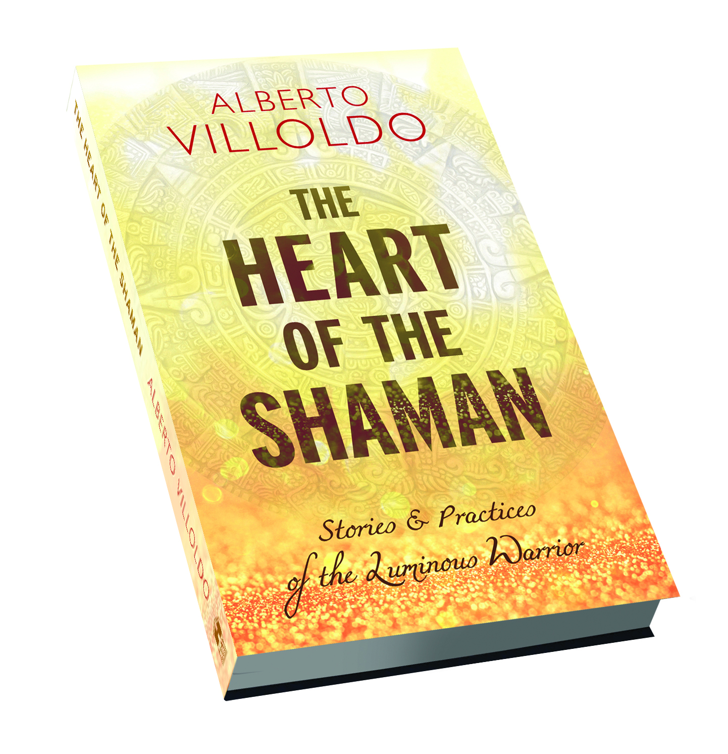
In his latest book, Alberto Villoldo sets his focus on what the shamans of Peru call the sacred dream—a powerful revelation that has the potential to guide us to our purpose and show us our place in the universe.

Villoldo explains how to recognize and awaken from the nightmare circumstances of our lives, find our sacred dream, and embark on a journey of transformation and healing. By discovering the light within and around us, we too become luminous warriors.

https://amzn.to/2t87ZR0

For the translations, please visit: http://theheartoftheshaman.com/

You can learn more about a lecture Robert Moss is giving titled: “Becoming a Quantum Dreamer: Experiment with Time Travel, Explore Parallel Worlds & Change Your Future for the Better”. Robert gave his talk on July 28, but you can listen to the replay.

https://shiftnetwork.isrefer.com/go/qdSI/ingerman/
Copyright 2018 Sandra Ingerman. All rights reserved.

