**Remote Transfiguration Experiment for Shamanic Journeying for Guidance and Healing Part 2 with Sandra Ingerman**Photos and report by Sylvia Edwards

This experiment was part of a class session taught by Sandra Ingerman in her teleconferencing course through the Shift Network.

Purpose: To test whether substances and people showed an energetic difference in conjunction with the class exercise of transfiguration. In the exercise, class participants were asked to gather around their virtual altar with the address of a room in a hotel in Broomfield, Colorado placed on the altar. They were then asked to see only perfection of all things – people and substances in the room, to drop their physical form and to let their divine light shine, holding it as long as was comfortable.   
  
There were 10 people this experiment as well as a variety of food and liquid substances. The people ranged in age from 4 years to 74 years old. In preparation for the remote transfiguration exercise, they were told to arrive a half hour to 45 minutes early. After they allowed their energy to stabilize in a relaxed setting, the pre-testing was done. The food and liquid substances were also pre-tested. The participants were asked to choose a metaphor for being open to receive and to visualize receiving during the ceremony.

About 15 minutes before the ceremony started, Sylvia Edwards listened in on the session via headphones. When the ceremony actually started, participants were asked to sit quietly and activate their chosen metaphor for receiving.  
  
When the ceremony was over, post testing was done of people and then substances and comparison was made of the before and after photos.  
  
Results:

For the participants, the energy shifted in all people. The majority of people had an expansion in their energy field and the quality of their auric fields improved. The participants made the following observations of their experience:  
 - I felt waves of energy coming towards me. The strength fluctuated  
 - I felt overwhelming light/heat the first third. Then after the second third, I felt saturated  
 - I fell asleep like a cat in the sun  
 - About ½ way through the ceremony, I became pleasantly hot. Smiled a lot!  
 - At the beginning I felt a heavy downward pull around my heart chakra. That quickly broke free and was replaced by an incredible lightness. My visual field had a lava lamp type scene with hearts forming and dissolving.  
 - Felt waves of fluid energy – colored – lots of blue like the northern lights. Felt embraced – enveloped in love and light.  
 - Big ball of light in center of room. Sunburn on my face.  
 - Not much to report. Felt very comfortable, relaxed and restored.  
 - At first the 4 year old felt really cold, then got really hot and saw purple flowers.  
 - Noticed a pressure around the bladder about mid-ceremony that passed by the end. Breathing also shifted during the ceremony.  
  
Here are some examples of the energetic fields of participants:  
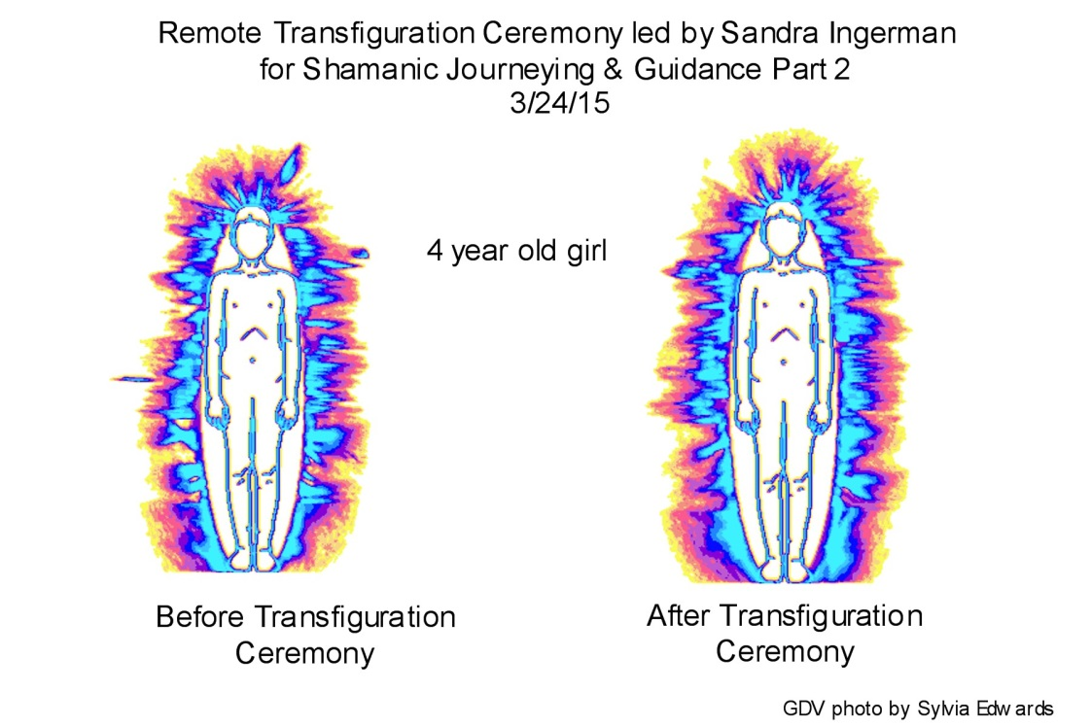  
In the left photograph notice the gaps in the auric field around the left side of the auric field near the thigh, the right side near the knee and the right side around the solar plexus. On the after photo, these gaps are filled in. The chord on the left side has also disappeared in the after photo.  
  
There are three colors in the auric field. The blue represents the physical body, red equals the emotional body and gold represents the spiritual body.  
  
The next example is of a 57 year old female.  
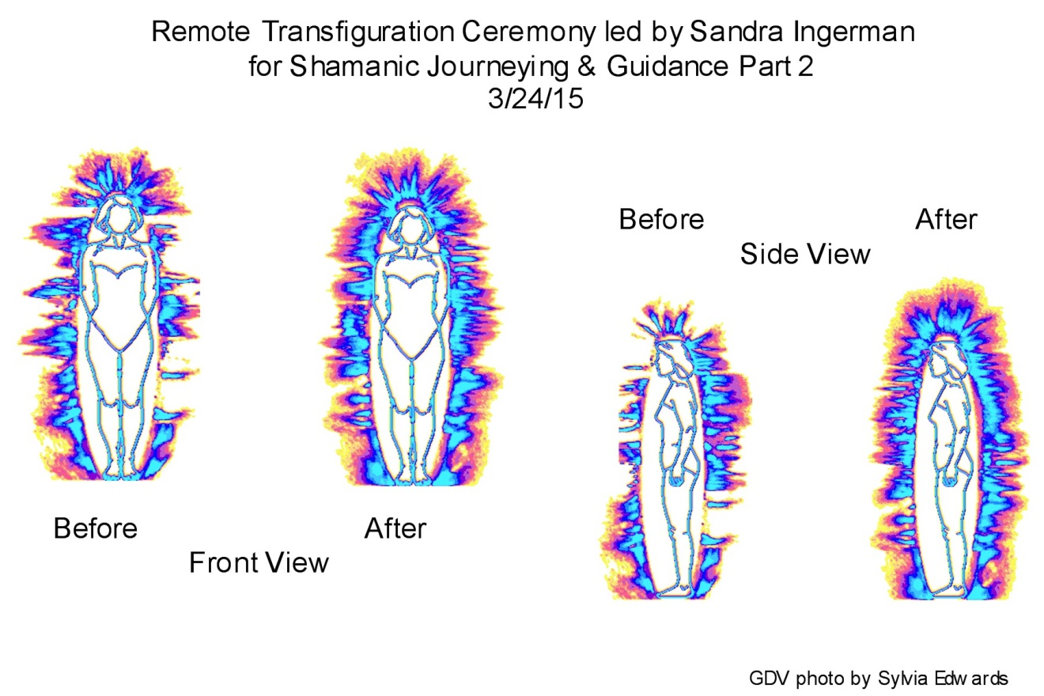  
In this one, many of the gaps are filled in and the aura itself is much more even.  
  
This next one is a 51 year old female.   
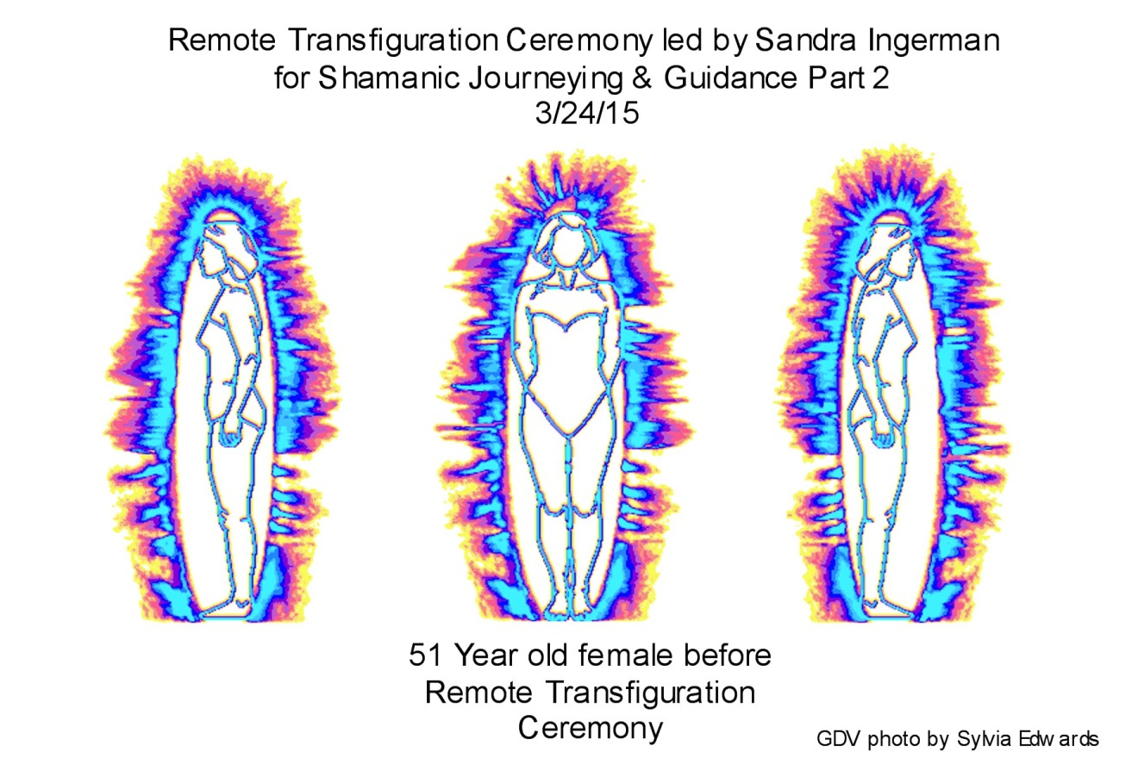  
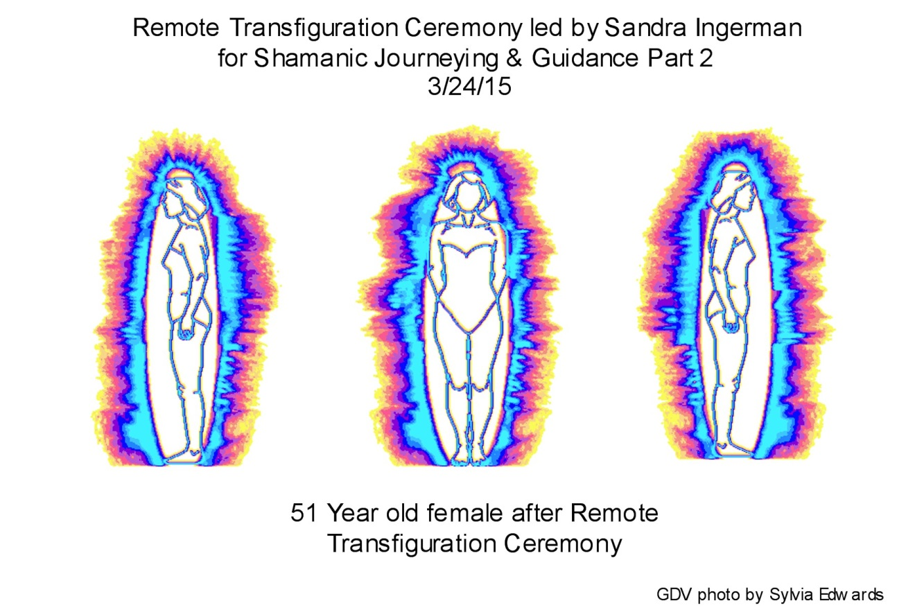

Again, the gaps are filled in, and the aura is smoother. This person, 3 days after the ceremony reported that she felt like the “edge” that she had been feeling had smoothed out.   
  
Substances:  
  
The liquids I tested were 3 types of bottled water, orange juice, milk, apple juice and some water from a natural spring. The before photos of these liquids looked organized and vibrant except for the orange juice. Below is a photo of the Orange Juice before and after.  
  
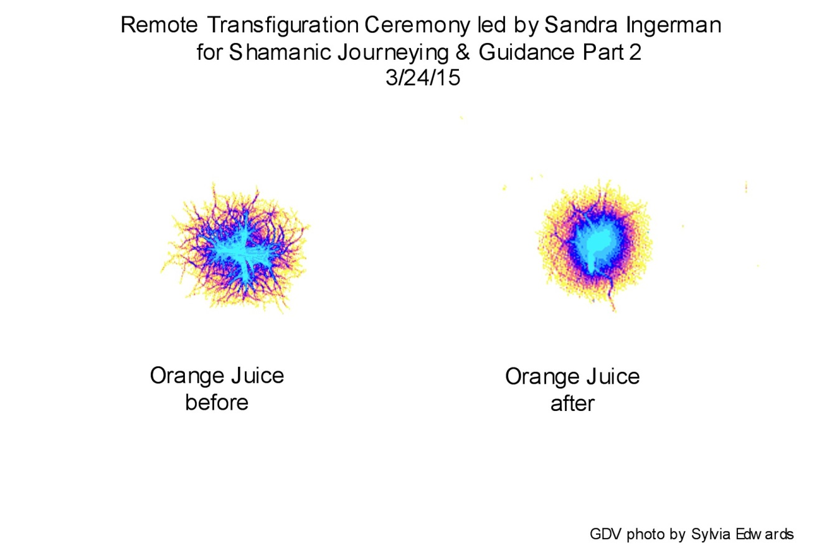  
The before photo on the left show a chaotic energy pattern. The one on the right shows coherence after the transfiguration ceremony. Coherence or organized energy is the desired effect of a drop of liquid.  
  
In the following photos, food substances showed a marked increase in life force energy and volume of the auric field.  
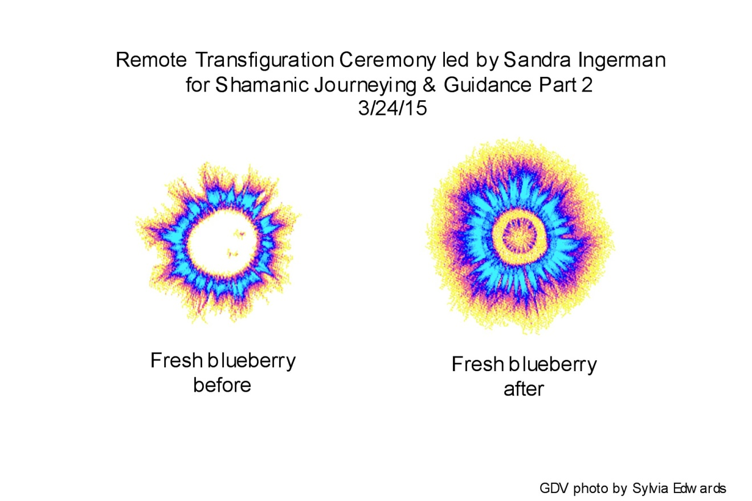  
The blueberries were “natural” blueberries from Whole Foods. The before photo looks vibrant, the one on the right is carrying much more energy.  
  
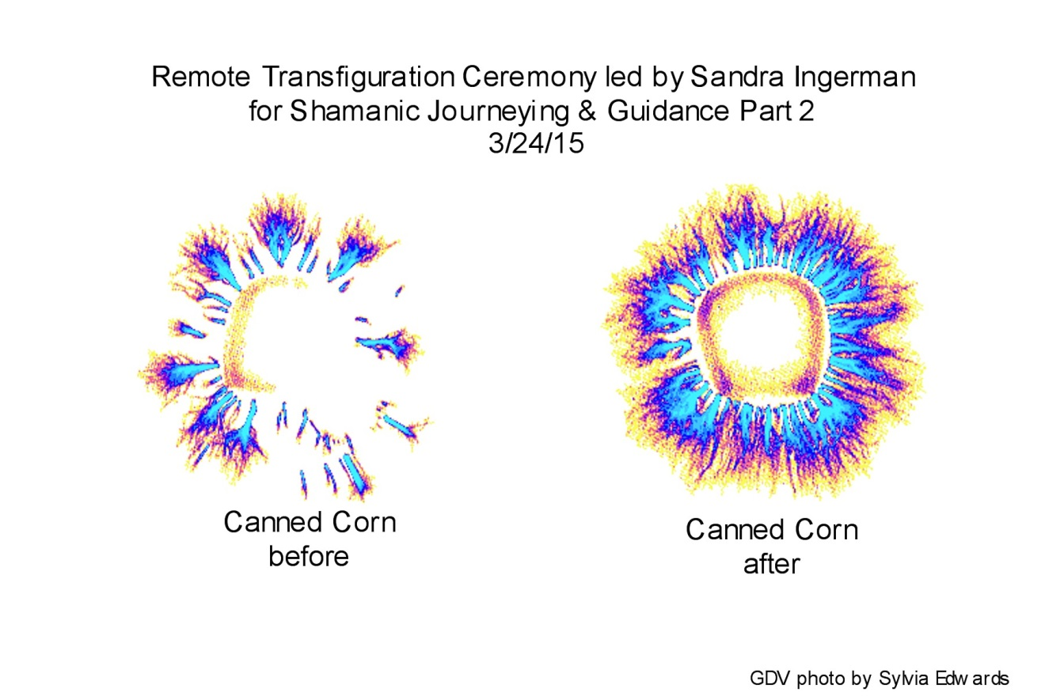  
The canned corn was the generic brand from Walmart. There is much more energy being emitted from the after kernel.   
  
Here is a photo of corn cut off the cob. These were purchased in a 4 pack from Walmart’s with the husk already taken off.  
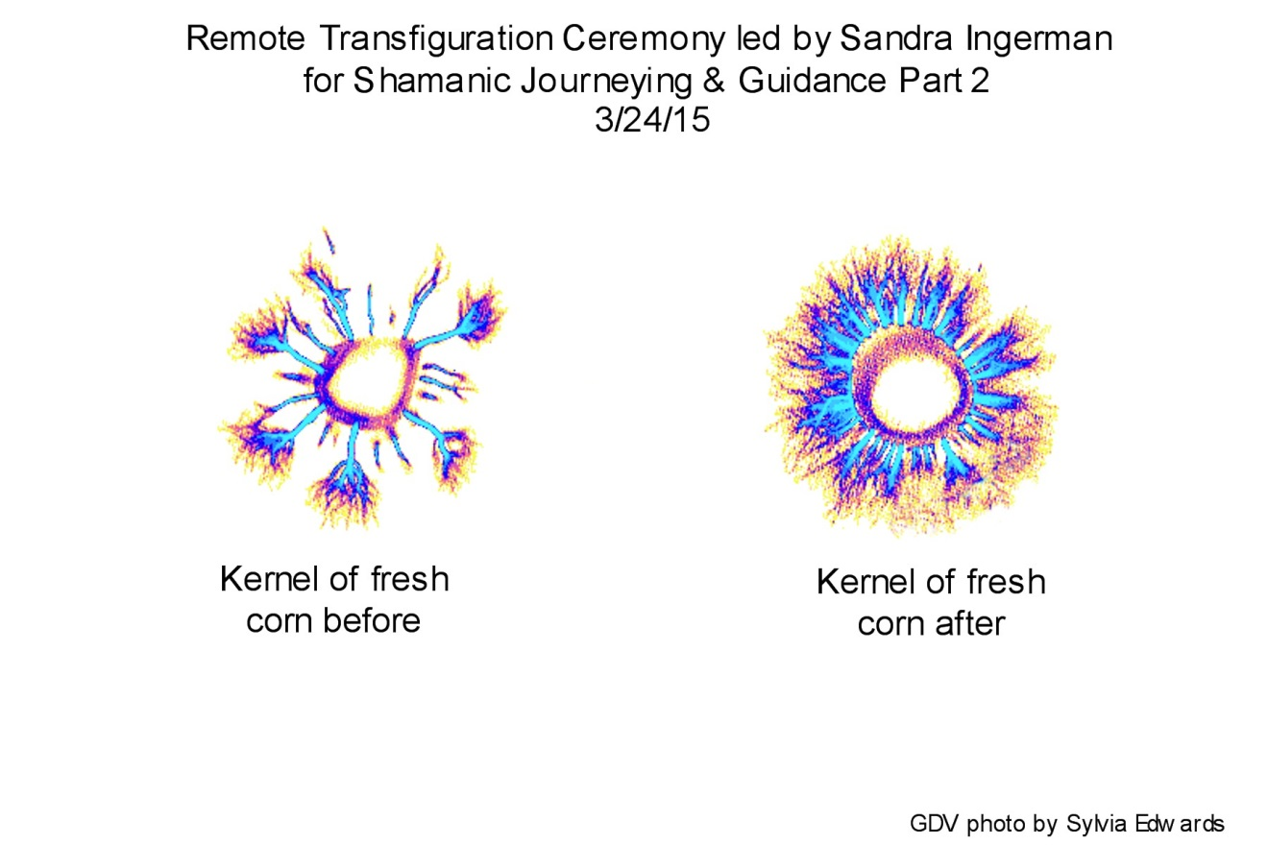  
The before and after photos of fresh corn look similar to the canned corn. There is speculation that a lot of corm products are genetically modified. While they aren’t labeled, this test could show the effects that transfiguration has on genetically modified foods.  
  
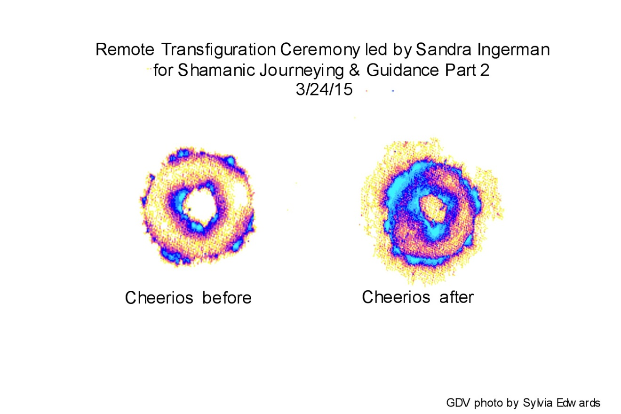  
Processed food is generally energetically dead food as is the case with Cheerios. The after photo show increased energy and vibrancy. The same thing happened with honey nut cheerios.  
  
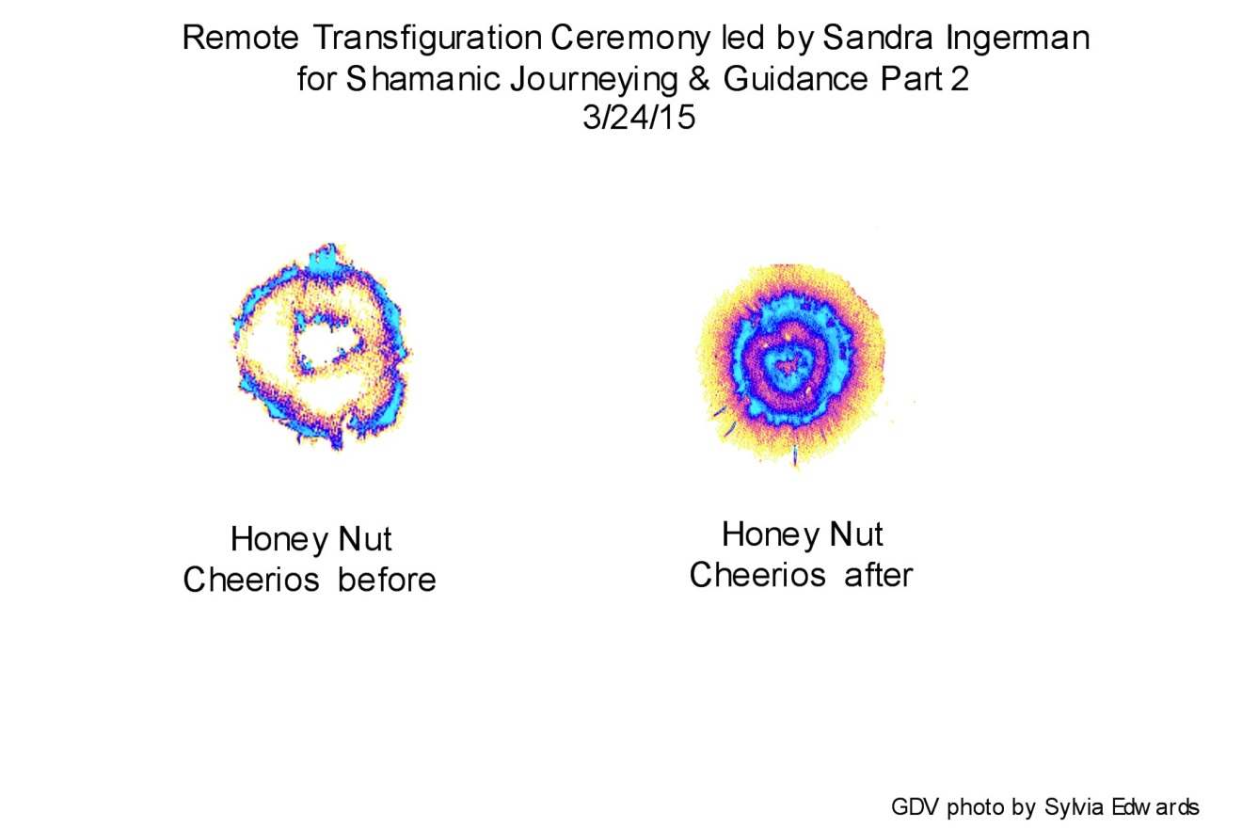  
  
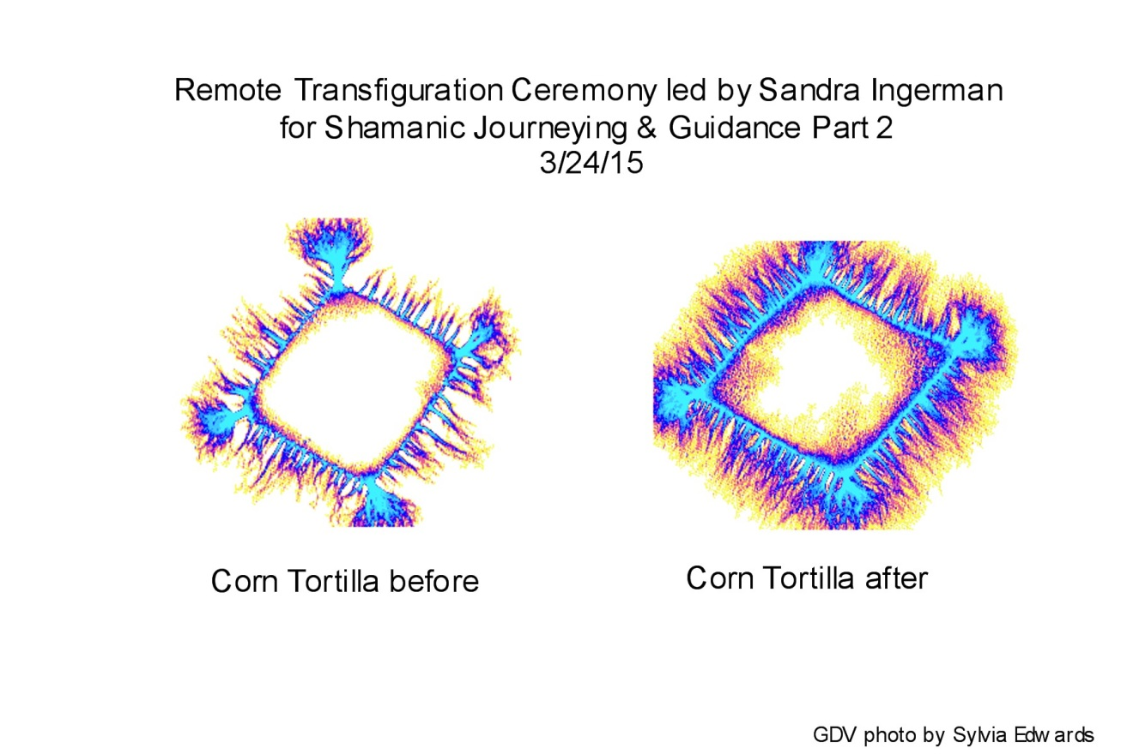  
  
The above picture is a piece of a corn tortilla showing the positive effects of being held in perfection.  
  
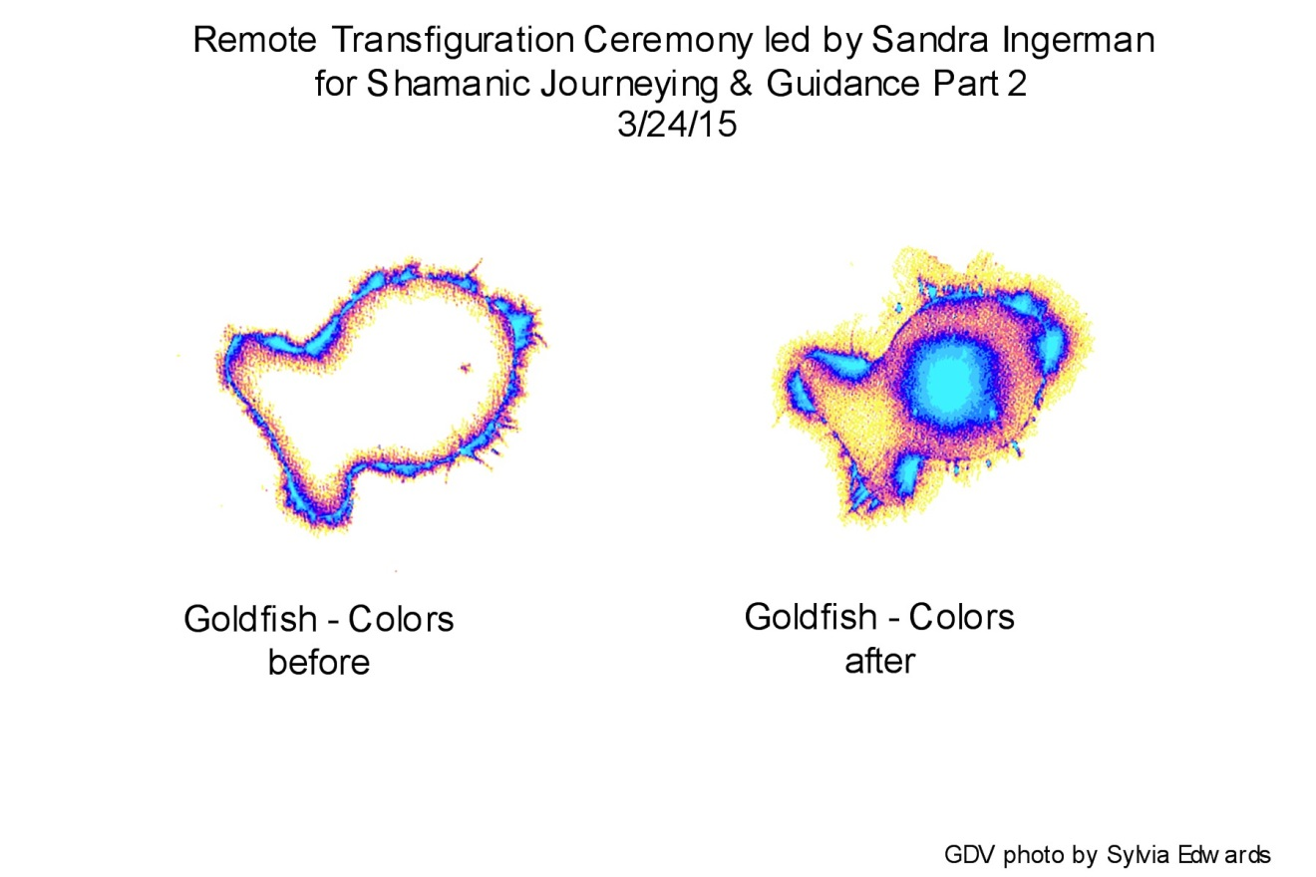  
This last picture is of Pepperidge Farm Goldfish crackers – Colors. Again, energetically dead before the ceremony and vibrant and energized after the ceremony.  
  
Conclusion:   
The perfection that was held for everything in room 427 of the Hyatt House in Broomfield, Colorado had a measurable effect on all people and the majority of substances. There were a couple of substances, like the water, that looked vibrant before the test and looked the same after the test. These included canola oil, mozzarella cheese sticks, fresh peas and pine nuts.  
  
Copyright 2015 Sandra Ingerman