Transmutation News May 2015

We all know the power of spiritual work. And we really do not need proof of the power. Just the fact that the practice of shamanism has survived for tens of thousands says all we need to know. For the power of the healing results keeps the work alive and thriving.

As there is a resurgence of shamanism in the West many of the people interested in exploring shamanic work do find learning about the results of the work helps them to open to the invisible realms. As we know through social conditioning most people in the Western world shut the doors to the invisible realm of spirit that we were so connected to as children. As people are searching for meaning in life today and ways to improve their health and well-being people are opening up to the possibility of working with the practice of shamanism. But many are still nervous about the practice for they were so conditioned to believe the world of helping spirits does not exist. We were so brainwashed into focusing all of our energy on the tangible realms and following the rules of society. It is sad as we could have strengthened society by supporting people in tapping into their spiritual guidance and helping to add to the collective strength of the whole. The good news is that people are waking up to this understanding now.

Since I started teaching Medicine for the Earth I have conducted different experiments with my groups to show how powerful the practice of transfiguration is for personal and planetary healing. I wrote about our beginning experiments in Medicine for the Earth: How to Transform Personal and Environmental Toxins. In our beginning experiments we worked with placing ammonium hydroxide in de-ionized water and tracking the change in pH.

We then moved onto working with the GDV camera that was created by Konstantin Korotkov. The GDV camera records the stimulation of photons and electron emission from people or objects placed on the glass of the camera. The software can manipulate that data to show chakra and auric fields in people and energy emitted from objects. It records emission and flow of energy in people and objects.

Sylvia Edwards has been using the GDV camera to measure results of the transfiguration work we practice at my workshops. We have witnessed numerous miraculous healings in these workshops! And at the same time it has been wonderful to have a way to show people the power of the work through having before and after photos available to view.

Just as a reminder with the transfiguration work no healing energies are sent. We as the practitioners transfigure into our divine light – who we are beyond our body and skin. And we perceive everyone and all substances we focus on in their divine light and perfection.

The practice of transfiguration uses the feminine principle of we create change by our presence and who we become versus what we do.

During a teleconferencing session I taught for the Shift Network I decided to work with Sylvia to design a remote experiment using transfiguration.

Sylvia rented a hotel room in the Boulder, Colorado area. She used the GDV camera to measure the auric field of volunteers who showed up to the hotel. And she also bought a variety of foods at the store to test. Some of the foods she bought most likely had GMO ingredients in them.

Then many hundreds of participants from around the world in my teleconferencing course transfigured and also focused on all the people and substances in the hotel room in their divine perfection and light. So again we did not send healing. We just perceived everything in the hotel room in divine light. The group had the name of the hotel, address, and the room number.

Sylvia listened on headphones as I guided the group in our transfiguration ceremony. None of the volunteers in the room knew what was happening in the ceremony. They were just instructed to absorb light. Sylvia took before and after photos of the people and substances present in the room.

To read a report and see the incredible photos please click on: http://www.sandraingerman.com/gdvcameraresults.html

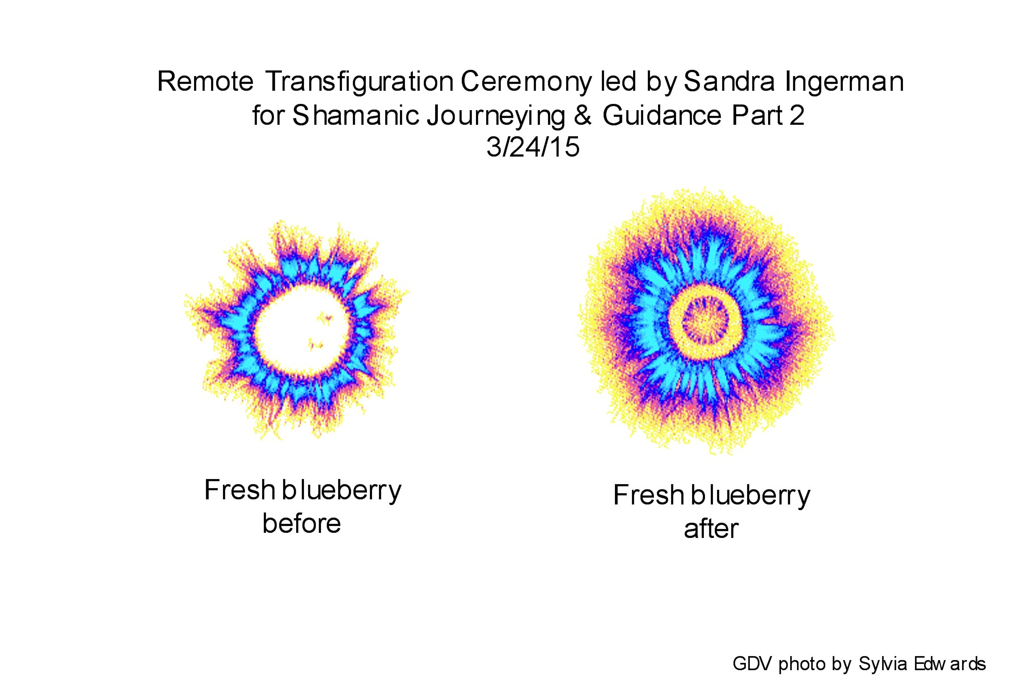
Then click on “Remote Transfiguration Experiment Report”. There are also incredible photos from other workshops that you can also view.

It was so exciting to work with an international group remotely. This inspired all of us and hopefully will inspire you to work on environmental issues using the practice of transfiguration.

Llyn Roberts and I wrote a new book that is being released on May 2. It is really a beautiful book and the pre sales of the book have been quite impressive. The book is titled Speaking with Nature: Awakening to the Deep Wisdom of the Earth.

One of the issues we speak about is how so many of us focus on the nature beings that the Western world talks about in popular culture. We speak about trees, plants, eagles, hawks, bear, dolphins, whales, elephants, and so on. And of course we are in love with those beings recognized by the collective.

But there are so many nature beings who contribute to the health and vitality of the web of life that we do not recognize in our conversations about nature – plankton, microbes, snails, earthworms, slugs, etc.

I thought this month we can become attentive to recognizing all beings in the web of life that include those we talk about often in our communities and those beings who rarely are recognized but are essential for the continuation and health of all of life. Think about a nature being that is not talked about in popular culture. Connect with it through a journey or meditation and witness how it contributes to the health and well being of the web of life. Perform a short ceremony to honor this living being.

Here is an excerpt from Speaking with Nature to inspire you:

Speaking with Nature Excerpt
Chapter 6
Banana Slug and Earthworm
Banana Slug
Llyn
Imagine strolling on a mossy trail in a dense, wet forest. You breathe in the freshly scented air, rich in oxygen and negative ions. It is springtime in the rain forest. Everything is green and flowing and blooming.
Seeming to walk with you on the lush and sopping trail, moving so slowly that you barely see it move at all, is a small, plump snail-like creature with no shell. Of the countless nature beings I live with in the Hoh River Valley, the Banana Slug is a prolific and intriguing presence.
Why are Banana Slugs called Banana Slugs? The skin of a Banana Slug is colored yellow with brown spots, like the casing of a ripe banana. . . .
Soft, fleshy, and fragile, the Banana Slug has no protective shell like its snail cousin.
Does Slug mirror our underbelly?
The divine feminine knows there is power in being vulnerable. Does this tiny being cause us to bristle because it hints at those parts of us that we deny or conceal? The sensual, sensitive aspects of the sacred feminine are still something many of us hide as well as hide from. . . .
How do we honor Banana Slug medicine, touch back into tactile Earthiness? One way is to learn from young children who love to lie on the grass gazing up at clouds and stars, run through summer downpours, and squish mud between their toes. The simple, sensual explorations that occupy healthy youngsters signal a hearty connection with body and the Earth. These kids are in touch. . . .
Spirit and body are inseparable. We are also one with our planet’s body. Touch is innate to who we are and how we know self, and world. Banana Slug suggests we get back in touch, with each other and the Earth.
Banana Slugs are vital to the decomposition of plants and spread seeds and spores across the forest floor. They are also amazingly sentient. Come to Slug with malice, and it retracts and plays dead. Speak in a soothing tone, and this fellow being may lift its head and turn to look at you. Chatting with Banana Slugs can make me weep.
Life would take a different spin if we also hugged the land like trusting and tender Slugs, who appear happy to be in their bodies here on Earth. The unguarded Banana Slug freely shares her deep feminine teachings: “Remember the sensual, and the power of little.”
Practice
Banana Slug wisdom tells us to get back in touch and empower the small.
Think on tiny aspects that largely impact your life in a positive way right now. Envision and appreciate these. Give energy to the little.
Open your heart and senses and see how alive the small makes you feel.
Remember little Banana Slug who is what it is and does what it does, nourishing and seeding the Earth despite the killing fields of cut forests all around.
Throughout all, meek and wise Banana Slug encourages: “Stay simple and in touch. You and I, we are just enough.”
Earthworm
Sandra
There is a quadrant of our garden that does not support the growth of much plant life. . . . We have consulted with many landscapers to examine the soil in this quadrant of our garden, for something in the chemical makeup must have changed to go from supporting many plants to only sustaining the very hardy. The issues seem to be beyond water.
I believe the issue is that the soil has become so hardened in this area by minerals and drought that the only solution is to bring in an army of earthworms.
Earthworms are tube shaped, segmented, hermaphrodites--each individual carries both male and female organs. They are both blind and deaf, but their skin is covered in cells that allow them to taste the soil and sense light and dark. Earthworms live in soil, burrowing themselves into various levels, naturally allowing oxygen to get in, which is beneficial for plant growth. They take leaves, leftover food, and anything they are able to decompose and turn it into fertilizer. They breathe through their skin and have five sets of double hearts in segments that are close to their head. . . .
There is such a weaving of mystery in creation, and we often miss the magic of how each and every creature in the web of life serves a role in creating, maintaining, and sustaining life. All in the web of life has something vital to share in creating a healthy earth garden. All life is interdependent on other life-forms.
Every acre of well-cultivated land contains up to half a ton of thriving microorganisms, not to mention up to a ton of earthworms. The earthworms create a ton of castings that are essential for the health of the soil, nurturing it with much needed nutrients that promote healthy plant growth. The mucus that the earthworms produce along with the castings promotes the growth of helpful bacteria and fungi.
Use your imagination to leave your ordinary life behind and take a journey with me into the world of the earthworm and the gift of its life.
Close your eyes and imagine yourself in a rich and fertile garden. As you examine the soil you are led to the small life-forms that are the tenders of the soil.
Using your invisible senses notice how microorganisms built the soil, but nature’s true tiller of the soil is Earthworm. Observe how these blind small beings are powerful diggers and earthmovers, capable of burrowing down as deep as fifteen feet. Watch as they force air through tunnels as they move. Experience amazement at how as they burrow they aerate the soil, mix up the soil, break down clumps, and bury stones. Watch as they carry down leaves and other organic matter, while others bring nutrients and humus to the topsoil. Earthworms cannot live without enormous amounts of decaying organic matter.
Return to your ordinary awareness with a sense of gratitude for how earthworms create healthy soil that supports the growth of food that sustains us.
We often judge the importance of the role of a person or a nature being. We tend to compare the power of life-forms based on their size and how colorful and loud they are. Llyn reminds us to honor and to acknowledge the power of small.
When you honor the small beings who are so vital to life you start to let go of your judgments and comparisons. You can without judgment tune in to yourself and acknowledge the gifts that you personally contribute to the web of life. And in doing so you feel on a cellular level that you are enough.
Practice
As you go about your day notice the people who you meet who are in service to the community and to the planet who do not need any acknowledgment. Honor the power of anonymity while doing your spiritual work and your practices on behalf of all of life.

Speaking with Nature by Sandra Ingerman, M.A., and Llyn Roberts © 2015 Bear & Company. Printed with permission from the publisher Inner Traditions International. www.InnerTraditions.com

The full moon is May 3. During the full moon let us honor all of life – the beings we do not usually think about, those who are always in our conscious awareness. Let us wake up to the beauty and wonder of all that is alive.

Perform some deep preparation work to move your ordinary consciousness out of the way. Step back from your daily thoughts and concerns. Perform a ceremony to travel within to experience your divine light – your inner flame of life, your inner starlight, your inner sunlight. Shine and radiate that light as you focus on all that is alive and our great Earth. Touch the Earth and all of life with your love and radiance. We join our love and light together as a global community to weave a radiant web of light into reality.

If you are new to reading the Transmutation News please visit “Creating A Human Web of Light” on the homepage.

Due to the wealth of information in this month’s column I will wait to continue sharing inspirational stories from our community until June.

Announcements:

To order my new books Walking in Light: The Everyday Empowerment of Shamanic Life, Speaking with Nature: Awakening to the Deep Wisdom of the Earth, also “Shamanic Visioning Music: Taiko Drum Journeys, or any of my other books and CD programs please visit:

http://www.sandraingerman.com/booksaudiovideo.html

I was asked to be contribute to a brilliant book edited by Tami Simon at Sounds True titled Darkness Before Dawn: Redefining the Journey Through Depression. This book includes a gathering of 19 exceptional and compassionate teachers who faced profound depression themselves who wrote about radically shifting the way that we perceive the experience. All the authors offer insights and practices that reach beyond conventional models.

You can order the book through your bookstore or SoundsTrue.com, Amazon, or Barnes and Noble.

Beginning May 1, 2015. Tami Simon will speak with today's leading teachers on the topic of spiritual awakening—what it is, why it matters, and how it changes our lives and our world. The series is yours to enjoy as often as you'd like for the entire month of May.

I was a presenter in this series. I really thought about what I would share as I knew Tami would have brilliant teachers sharing a true wealth on this topic. And I wanted to share something that might shed light on a different aspect of spiritual awakening.

I ended up focusing on how we must be fully embodied in order to engage in practices that lead to spiritual awakening. I thought my interview with Tami was quite powerful.

Registration is open now:

http://www.soundstrue.com/store/wakingup

I also wanted to let everyone know that Llyn Roberts and I will teach a weekend workshop November 13-15 2015 at Esalen Institute on the material in Speaking with Nature. You can visit www.esalen.org for more information.

I am still working on my 2016 calendar. I really over committed myself the last couple of years with writing books, recording CDs, and teaching. I feel I need time to regenerate. I will be taking a semi sabbatical in 2016. But I have scheduled a Five Day Soul Retrieval Training at Joshua Tree Retreat Center for 2016. And I am also teaching a 7 week teleconferencing course through the Shift Network in 2016. I will be in the middle of teaching two Two Year Teacher Trainings in 2016 so I will not be adding any more Teacher Trainings to my schedule at this time. I will keep you posted as more information on my courses in 2016 becomes available.

I will be co-presenting with Llyn Roberts on the Inspiring Women Conference through the Shift Network. Please see the write up below.

And I so delighted to announce the Transmutation App is now available in the Android Version!!! Yeah! Please see the write up below.

Once again I have been invited to be a presenter in “The Inspiring Women Summit” that the Shift Network is putting on May 1-4. I will be presenting with Llyn Roberts and we will talk about the amazing power of nature to heal and reconnect all of us to joy, health, and flow in harmony with the river of life.

As women, we each have access to a wellspring of deep wisdom... we just need to remember how to tap into it.
However, in a culture that places so much emphasis on productivity, “getting ahead” and doing, it’s easy for us to lose touch with the things that most nourish our radiant feminine essence.

That’s why I want to invite you to The Shift Network’s free online Inspiring Women Summit, taking place May 1-4, 2015.
I’m honored to be among 25+ visionary women – including people like Marianne Williamson, Sandra Ingerman, Sue Morter, Caroline Muir, Chameli Ardagh and others – who will take you on a liberating journey to more complete soul satisfaction.

It’s actually one of the largest virtual gatherings of women in history! In past years, 60,000 women from more than 95 countries have come together for these dialogues.

Register for The Inspiring Women Summit now, and get ready to embark on a journey that promises to deeply enrich your life.
https://shiftnetwork.isrefer.com/go/iws15si/ingerman/

I am so delighted to announce that the Transmutation App I designed is now available as an Android version.

We continue to talk about how we wish to heal the waters of the world and the Earth. From a spiritual perspective our outer world is a reflection of our Inner World and our inner state of consciousness. The only way we will see true transformation on the Earth is if we do our inner work.

You can buy the Android version on Google Play.

https://play.google.com/store/apps/details?id=net.stonescape.transmutation&hl=en

You can buy the Android version on Amazon by visiting:

http://www.amazon.com/Sandra-Ingerman-Transmutation/dp/B00URWQB2W/ref=sr_1_1?ie=UTF8&qid=1426779477&sr=8-1&keywords=transmutation+app

And as you know the Transmutation App for Apple devices has been available for many months now. For those of you needing the link for the Apple link it is:

https://itunes.apple.com/us/app/transmutation/id889658056?mt=8

I have been working with the App for over a year now, and it is such a valuable tool for me to help me keep my focus on my spiritual work and feeding all of life with love and light.

The Transmutation App improves your state of health and well being by assisting you to transform your negative thoughts that arise throughout the day. It is important to break the habit of dropping into defeatist thoughts and attitudes and learn how to stop yourself from entering into a negative loop that blocks you from achieving your desired outcomes.
The Transmutation App helps to shift the way you think throughout the day and will help to uplift you during challenging times. You are not denying any feelings you are experiencing. Rather it is a process of rephrasing your thoughts to change your train of thought which will lead you to a positive outcome.
You can program the app for the interval of when you would like to receive an alert of bells, a Tibetan bowl, or chimes being played. When you hear the alert you will read the message that asks you to reflect on: "What are you thinking about right now?" Your thoughts and words are seeds that when planted into your inner garden will grow into plants that do impact your life. It is important to cultivate a deep and rich inner garden to create true joy and health in your life.
Once you receive the alert go into the Library and tap on the category “word”, “phrase”, “blessing”, or “photo”. A word, phrase, blessing, or photo will appear that will inspire you to stop your current thinking and transmute/transform any negative thinking into positive thoughts. This will also help to shift your attitude and even create an inner smile.
You can use the words, phrases, blessings, or photos provided. Or you can upload your own.
The result will be that you will experience feeling more uplifted. In this way you feed yourself with love and light. This will improve your life, giving you more energy, and help you to be more creative in your life and in your work. You will be able to radiate love and light towards yourself, your loved ones, friends, co-workers, and into the world.
don Oscar Miro-Quesada is a brilliant shamanic teacher who has a depth of wisdom to share.
On May 6 you can listen to his free intro call on the Shift Network titled: Condor Medicine: Shamanic Wisdom, Healing and Ritual Magic from the Spirit World.
To register and for more information please visit:
https://shiftnetwork.isrefer.com/go/cmSI/ingerman/
Also I wanted to let you know about a free introductory call Luisah Teish is giving through the Shift Network. Her intro call is titled The Power of Myth to Create a New Millennium: How Art, Ritual and Story Can Heal Our World and it will air on May 13th. The registration page will be finalized on April 30th.
https://shiftnetwork.isrefer.com/go/pomSI/ingerman/
Copyright 2015 Sandra Ingerman. All rights reserved.

