Transmutation News November 2017 Download printable version

In the last few issues of the Transmutation News I have been sharing how people are writing me about being in a state of despair and having a hard time keeping up with their spiritual work. Well now these communications being shared with me are changing in ways I did hope for and expected.

With all that is going on in our inner our outer worlds we are truly going through a death. And as Elisabeth Kubler-Ross so brilliantly outlined there are different phases as a person prepares for death and also when people experience grief. Of course, she was referring to people given a terminal diagnosis. But these phases certainly pertain to the death of our current egoic state of consciousness. The phases she described are not in a particular order, and she also admitted some people never experience these stages. But I find them remarkable as I have worked with so many people facing death and experiencing deep states of grief.

First there is denial. And then there is the anger that life is changing in ways that seem bleak as we look out of our human eyes. When great shamans gaze out of their eyes they look beyond this material world we are living in into other dimensions of reality where hope and healing are always present. After people move into states of anger they might move into bargaining with a divine force for a miraculous healing

At some point anger about death and change can transform into acceptance. Some people perceive that acceptance is giving up. And that is not true. For even with acceptance we have tools to stand strong together and continue our work and not give up on our dreams. At the same time when we accept that a death is occurring we actually learn how to adapt to the necessary changes occurring so we can move back into a state of balance.

And what people are starting to communicate to me is that with the “ego death” being experienced and the sculpting away of lives people are experiencing deeper journeys, ceremonial work, and healing work. The current crises we are in are actually opening up the veils between the worlds where greater insights and guidance is waiting for us. And the path between the ordinary and the non-ordinary realms is getting shorter as we learn to shift our perception and gaze into dimensions beyond this one as shamans have done for millennia. And in that gazing into these other dimensions of reality we truly can bring through higher energies to help us make the much needed shifts into rebirth and illumination. These phases follow any death and dismemberment experience.

In the United States November is the month where Thanksgiving is celebrated. Each year I write the same message. In shamanic cultures every day was a day of Thanksgiving. The sun was greeted and welcomed each day. Each community member greeted the sun with gratitude for the life and energy it provided all of life to thrive. Gratitude was given for life on a daily basis and for the plants and trees that helped to heal and feed the community and the abundance of animals that sacrificed themselves so that others could eat and survive. Through the power of such gratitude and acts of honor and respect flow and balance was created between the people and the elements earth, air, water, and the sun.

And people focused on their greatest dreams and visions daily instead of feeding what was not working in their outer world. There was gratitude for the wealth and treasures of the divine forces that live within each of us.

Everyday was a day of Thanksgiving, and we could create such potent dreams if we would bring this simple and most magical spiritual practice into our daily life. For whatever is happening in life we always have life itself to be grateful for.

The full moon is November 4. The full moon is always a powerful time to join our collective energies together to radiate light and share unconditional love with all of life as we continue to weave a beautiful web of light within and throughout the Earth. Remember to do your preparation work so you can truly step into your divine light and join our global community as we shine and focus on all the places on the planet that can use spiritual healing at this time of dismemberment and rebirth.

If you are a new reader of the Transmutation News please read “Creating A Human Web of Light” on the homepage so you can learn the instructions for our full moon ceremony.

Inspirational Story for the Month

Thank you Anne for sharing the following story and photos! We wish you the best of health!

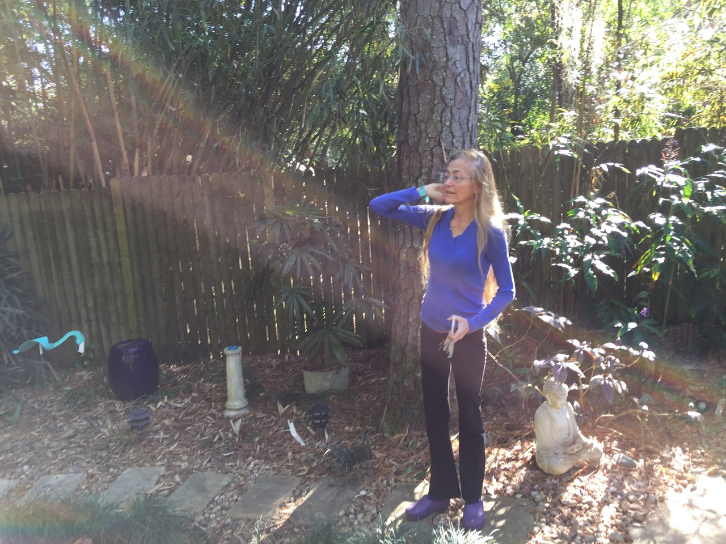
Just before the surgery to remove my left kidney and ureter, my sister and I were with my husband in our backyard. I was walking slowly on a path flagstone meditation path near the Buddha. It’s mid December, I had already had 2 exploratory surgeries and knew that I had cancer and that it was serious, life-threatening. As I walked, I communed and prayed to the Helping Spirits, to Buddha, letting go of all expectations of outcomes. My sister took this photo as I walked. The wintery sun was angled from the South, there was nothing in the material world that could have caused this rainbow light shining directly on to the area where the operation would occur and where the cancer was located. Spirit’s answer- all deep healing comes from Spirit. Trust!
Announcements:

To order my books Walking in Light: The Everyday Empowerment of Shamanic Life, Speaking with Nature: Awakening to the Deep Wisdom of the Earth (co-written with Llyn Roberts), my CD “Shamanic Visioning Music: Taiko Drum Journeys”, “The Spirit of Healing” or any of my other books and CD programs, the Transmutation App (now available for both Apple and Android devices) please visit: http://www.sandraingerman.com/bookscds.html

I recently had the remarkable opportunity to be interviewed by Nick Polizzi of Sacred Science. Nick Polizzi and his team brought 8 people dealing with a variety of serious illnesses to the Amazon to work with shamans. The results were simply incredible. And they made a brilliant film about their work.

The interview I did with Nick is filled with a wealth of information about shamanism. I hope you will watch it by clicking on the link below. There is the video you can watch as well as a transcript of the interview.

http://www.thesacredscience.com/a-modern-day-shaman-shares-her-wisdom/

Nick Polizzi’s blog is truly incredible. He has fabulous guests who share such wonderful information to help us all improve our health and our lives. Check out Nick’s blog and the website and all that is available on www.sacredscience.com

In the midst of tragic events going on in the world shamanism provides tools for people to learn how to practice shamanic journeying, deep listening in nature, dreaming work, and ceremonial work for personal healing, working with clients, and for being in service to the planet and all of life.

I am delighted to announce that I have booked Sedona Mago Retreat Center in November 2018 to begin a new Two-Year Teacher Training. In this course participants will learn how to teach shamanic journeying, Extraction work, the Five-Day Soul Retrieval training, how to work with death and dying including psychopomp work, and Medicine for the Earth and Healing with Spiritual Light. I will share what I have learned in my 35 years of teaching about handling group dynamics and how to create a powerful circle as well as multiple ways to set up trainings and train practitioners. We will also explore the personal work we need to do as teachers and practitioners to be great teachers coming from a true place of spirit versus being guided by our ego.

This work is such a gift to bring into our communities. For whether students want to work on themselves or others the times we live in call us to turn to spiritual practices for guidance, insight, support, and healing. And as shamanism is still being practiced around the world after 100,000 years says more than I can ever say about the positive results of the work.

If you would like to learn about the prerequisites for the course as well as the information about applying and registration you can visit: http://www.sandraingerman.com/trainingsannouncements.html

There will be four 5-day sessions. The first will be in November 2018. We will continue in the fall and spring of 2019, and end in the spring of 2020.

The best teachers teach from their experience and not from their notes. So all prerequisites must be completed before applying for the course.

The Medicine for the Earth and Healing with Spiritual Light scheduled for May filled immediately. Sounds True is compiling a waiting list and there are always people who drop out. To get your name on the list here is link: https://www.soundstrue.com/store/sandra-ingerman-estes-park

Please remember that there are brilliant Medicine for the Earth and Healing Spiritual Teachers listed on www.shamanicteachers.com. There are workshops all over the world you can attend.

Jeff Nixa is a brilliant shamanic practitioner and teacher listed on www.shamanicteachers.com He teaches powerful workshops as well as leads vision quests. Jeff wrote a remarkable book The Lost Art of Heart Navigation: A Modern Shaman’s Field Manuel. I love Jeff’s writing style and his storytelling. I hope you will check out this book that is published by Bear and Company.

I was gifted with a copy of the small and beautiful book Hobo Metaphysics. It was written by John Michael who spent years living homeless on the streets. He lifted himself up and now lives a very full life. The first couple of pages of the book is John’s story. And then following each page has one inspirational sentence or teaching. I was so touched by his gift and the heart felt wisdom he shares, I told John I would announce it for all of you who might be interested. You can learn how to order his book by going to his Facebook page at: https:www.facebook.com/geoff.johnson.982.
Copyright 2017 Sandra Ingerman. All rights reserved.

